# Week3 – Create CSS animated Advertisement

## Storyboard – design, a mock-up, a planning

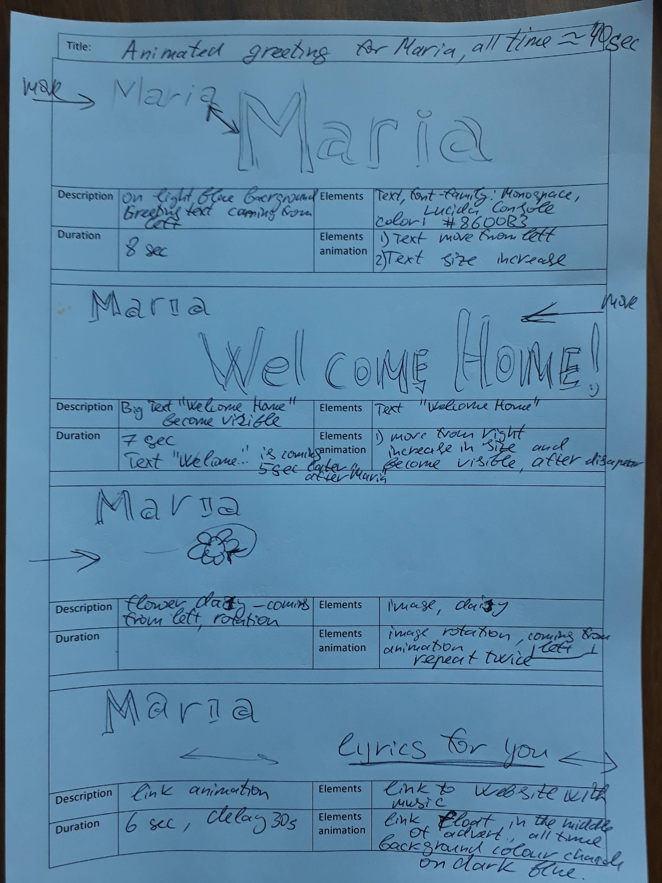

Before you start programming you need to draw a storyboard. It is help to clarify your idea and help to think about any elements involved and any animations happened. You need to put a different details like specification of colour, size, animation, may be a font size and font type.

## Development - CSS code only

Please test your page after each step and compare with online example, Also it will be a good idea save each working version as a new page ( like step1.html)

Please use w3school website for your references as well.

<http://www.w3schools.com/>

## Step 1 - Greeting move

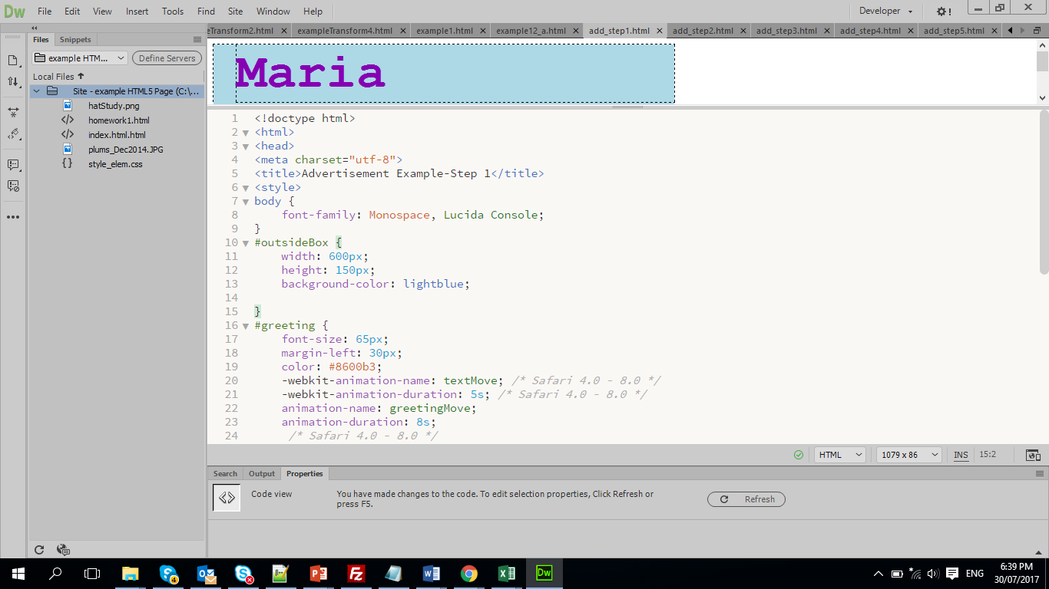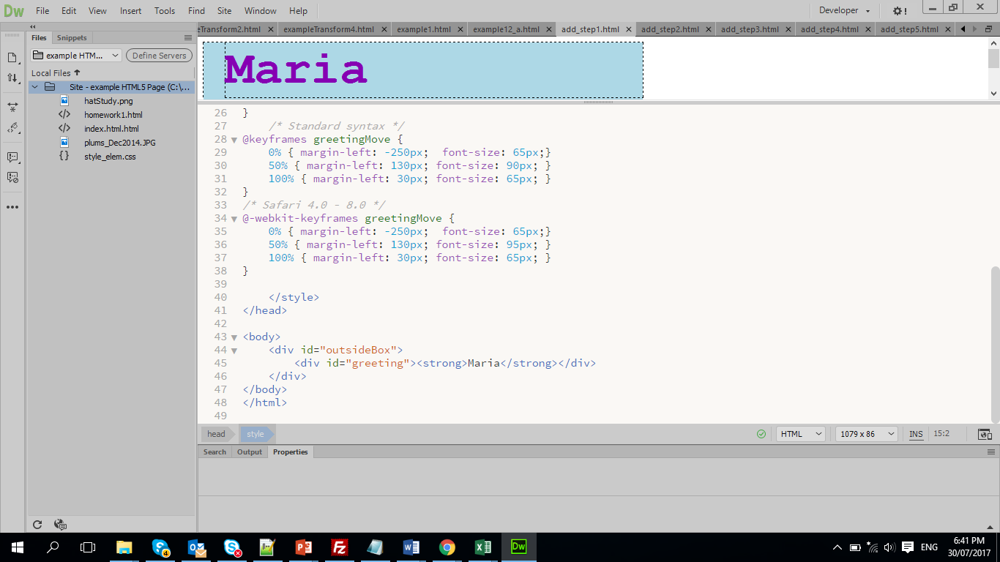

## Step 2 – Add a “Welcome Home!” animation

Make a change in the HTML code

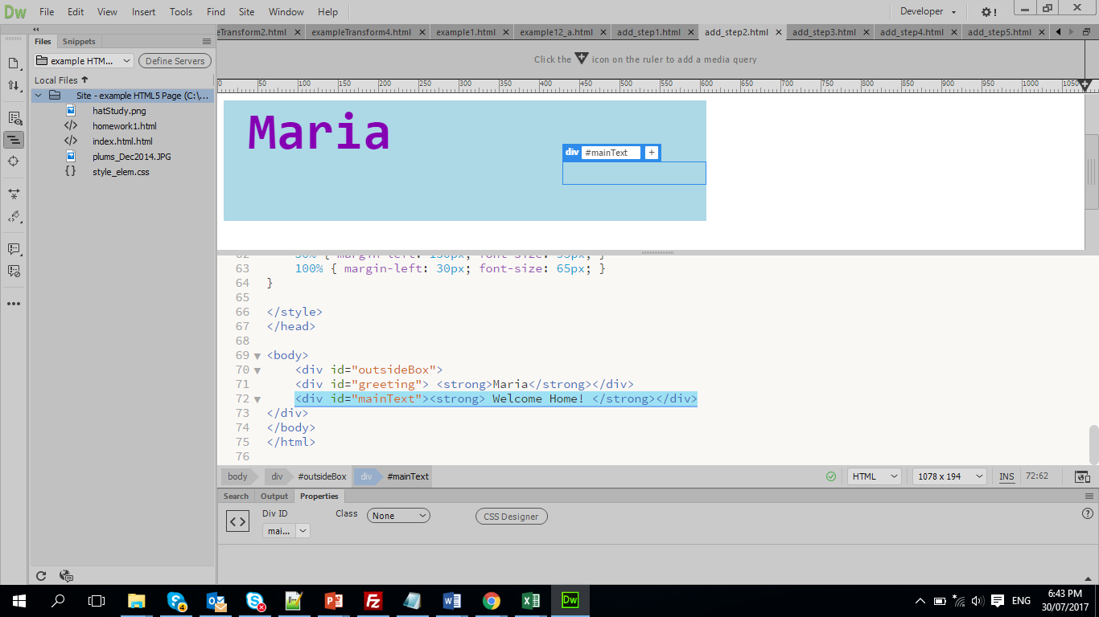

Add a CSS style with animation:

This is a delay; our animation will start 5 seconds later.

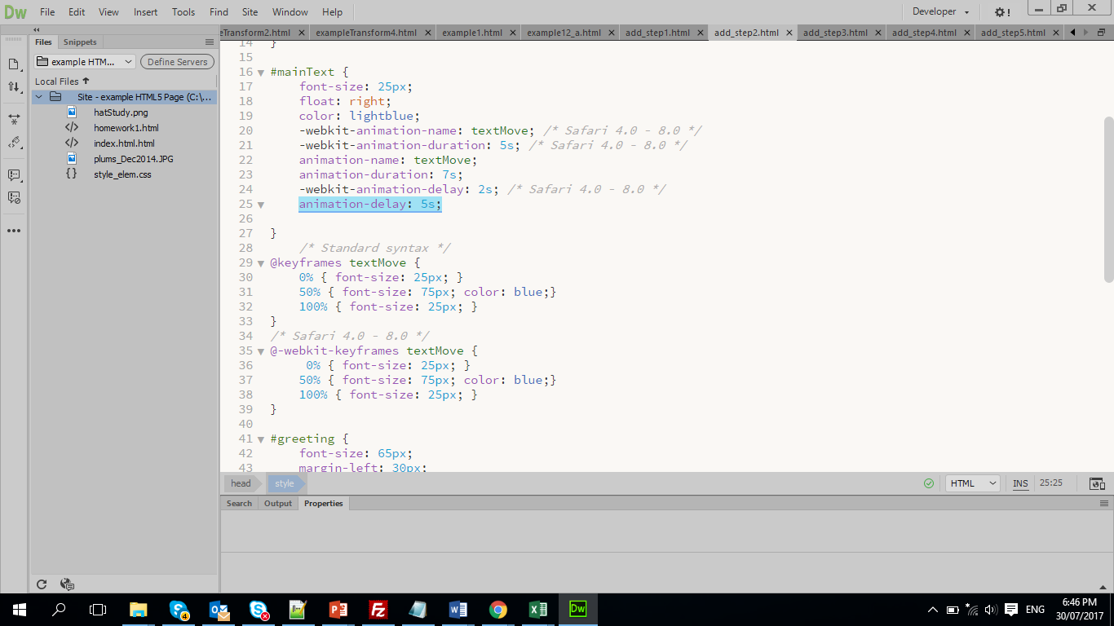

## Step 3 – Moving image with rotation, loop

This is a container for our small image, (have image in the same folder as your html file)

Make a change in the HTML code

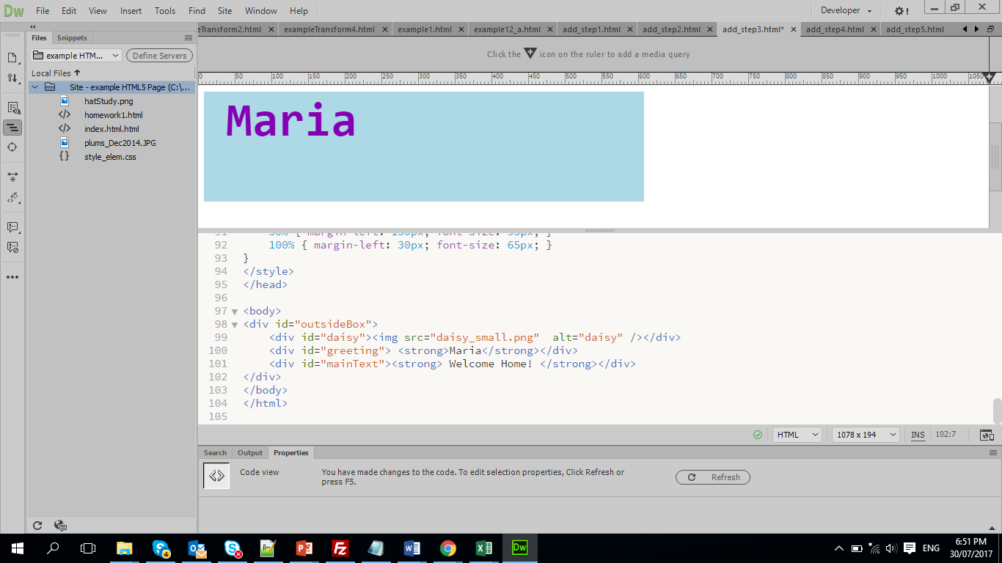

Add a CSS style with animation,

Note use of

This is a loop, how many times to repeat animation

animation-delay: 10s;

animation-iteration-count: 2;

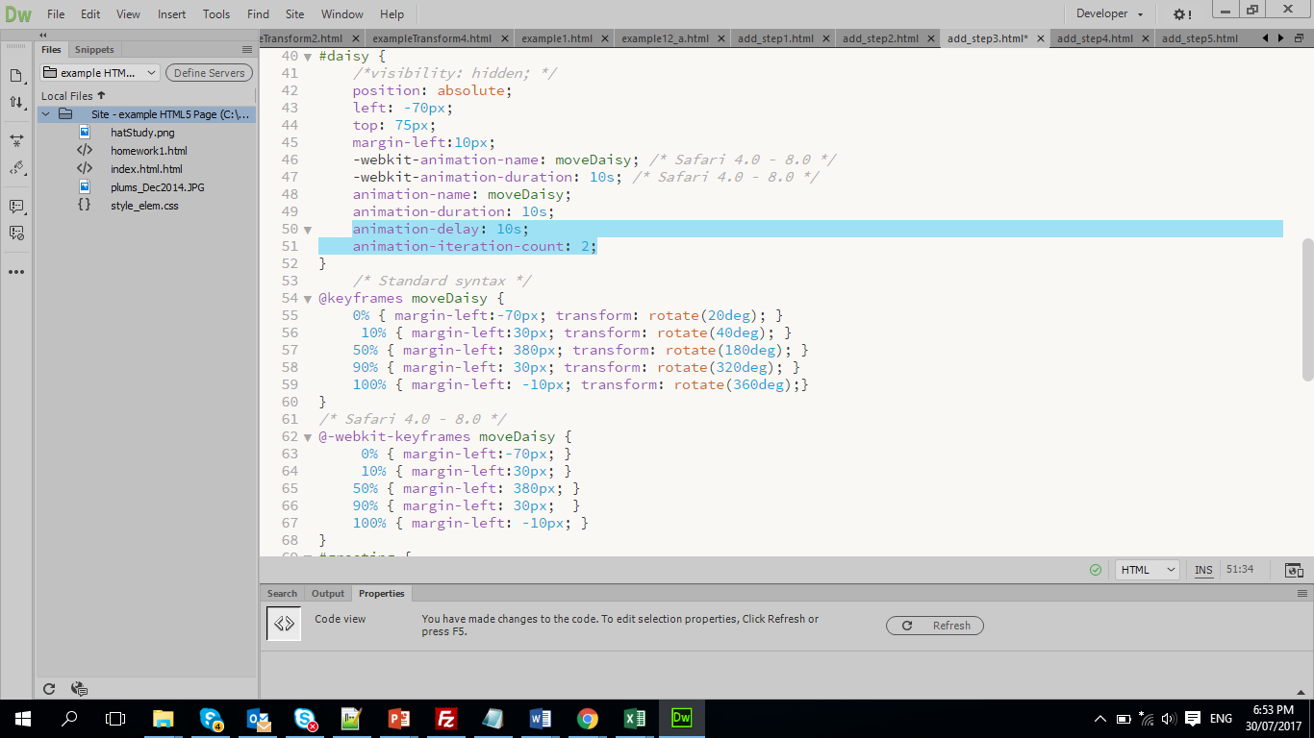

## Step 4 – Moving link with infinitive loop

This is a container for the link to the advertised website. Put target =”new” this will open a link in a new tab.

Make a change in the HTML code

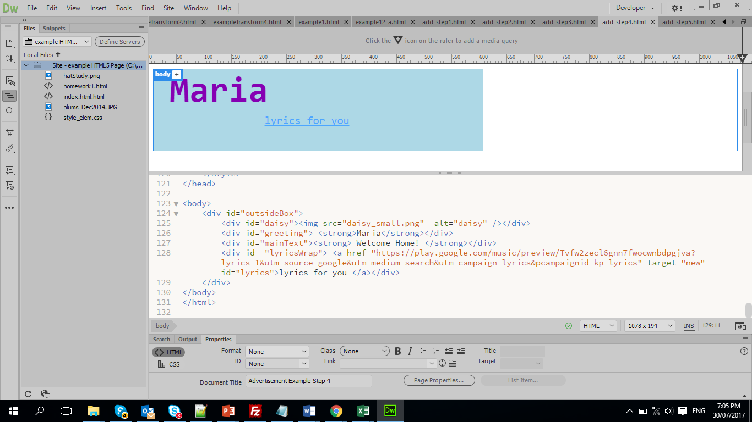

Add a CSS style with animation,

This is animation has delay 30s.

This is animation will all time to repeat, as it has an infinitive loop

Note use of

animation-delay: 30s;

animation-iteration-count: infinite;

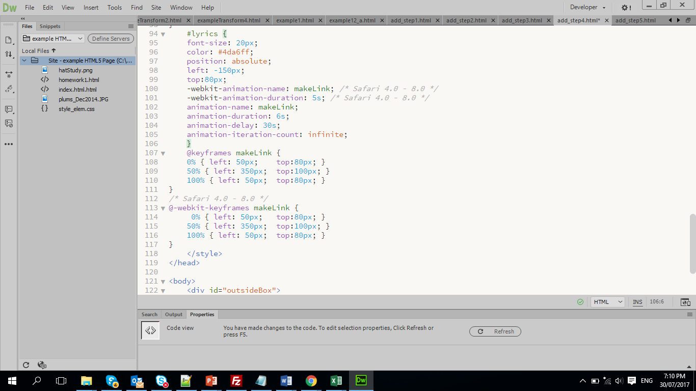

## Step 5 – Animate background colour

Make a change in the CSS style for #outsideBox

This is animation has delay 30s.

This is animation run for 6s only.

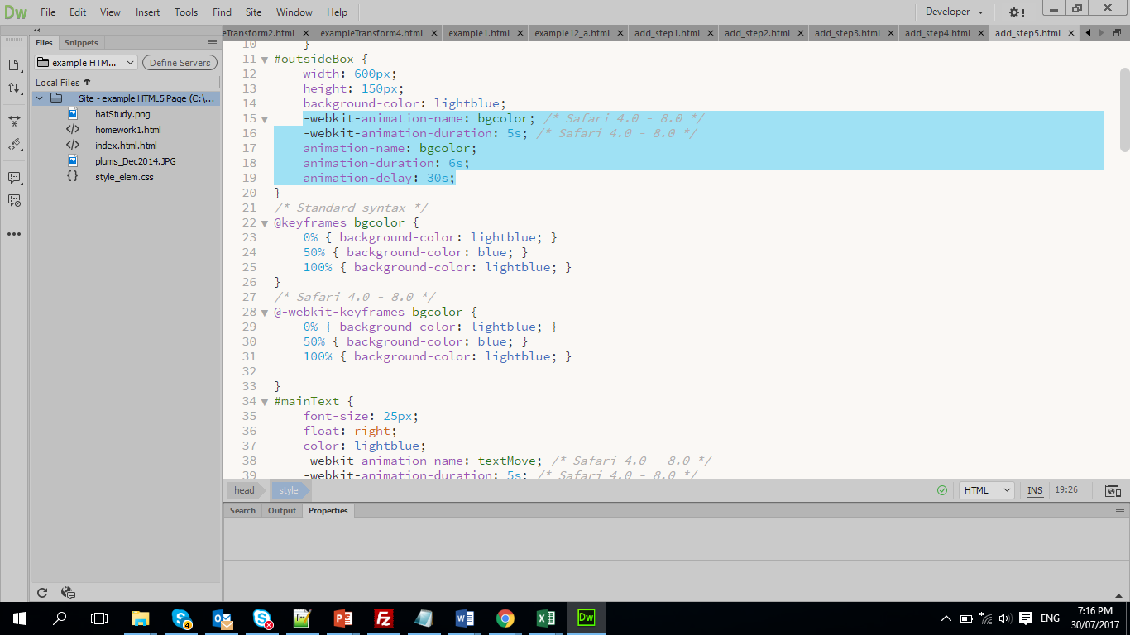

## Practice

Task 1 – Looking on existing advertisement develop a storyboard, put all necessary details: like duration, delay, length of animation, elements (text, images, links), desired colour schema, etcetera.

Task 2 – Plan your own advertisement banner for your homepage, develop a storyboard, with all necessary details: like duration, delay, length of animation, elements ( text, images, links), desired colour schema, etcetera.